Contents

is_comment 2

is_keyword 3

is_char_constant 4

is_num_constant 5

is_str_constant 6

is_identifier 7

print_spec_symbol 8

is_spec_symbol 9

main 10

# is_comment

|  |  |  |  |  |
| --- | --- | --- | --- | --- |
| Block Number | Lines | Entry | Exit | Function Calls |
| 1 | 265 | 265 | 265 |  |
| 2 | 266 | 266 | 266 |  |
| 3 | 268 | 268 | 268 |  |

# is_keyword

|  |  |  |  |  |
| --- | --- | --- | --- | --- |
| Block Number | Lines | Entry | Exit | Function Calls |
| 1 | 278 | 278 | 278 |  |
| 2 | 280 | 280 | 280 |  |
| 3 | 282 | 282 | 282 |  |

# is_char_constant

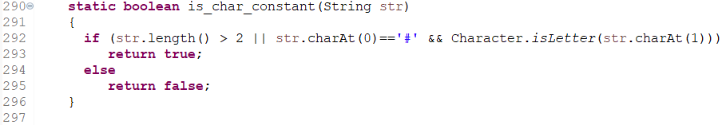

|  |  |  |  |  |
| --- | --- | --- | --- | --- |
| Block Number | Lines | Entry | Exit | Function Calls |
| 1 | 292 | 292 | 292 |  |
| 2 | 293 | 293 | 293 |  |
| 3 | 295 | 295 | 295 |  |

# is_num_constant

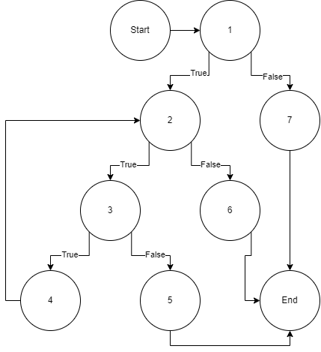

|  |  |  |  |  |
| --- | --- | --- | --- | --- |
| Block Number | Lines | Entry | Exit | Function Calls |
| 1 | 305, 307 | 305 | 307 |  |
| 2 | 309 | 309 | 309 |  |
| 3 | 311 | 311 | 311 |  |
| 4 | 312 | 312 | 312 |  |
| 5 | 314 | 314 | 314 |  |
| 6 | 316 | 316 | 316 |  |
| 7 | 319 | 319 | 319 |  |

# is_str_constant

|  |  |  |  |  |
| --- | --- | --- | --- | --- |
| Block Number | Lines | Entry | Exit | Function Calls |
| 1 | 328, 330 | 328 | 330 |  |
| 2 | 331 | 331 | 331 |  |
| 3 | 332 | 332 | 332 |  |
| 4 | 333 | 333 | 333 |  |
| 5 | 335 | 335 | 335 |  |
| 6 | 337 | 337 | 337 |  |
| 7 | 340 | 340 | 340 |  |

# is_identifier

|  |  |  |  |  |
| --- | --- | --- | --- | --- |
| Block Number | Lines | Entry | Exit | Function Calls |
| 1 | 350, 352 | 350 | 352 |  |
| 2 | 354 | 354 | 354 |  |
| 3 | 356 | 356 | 356 |  |
| 4 | 357 | 357 | 357 |  |
| 5 | 359 | 359 | 359 |  |
| 6 | 361 | 361 | 361 |  |
| 7 | 364 | 364 | 364 |  |

# print_spec_symbol

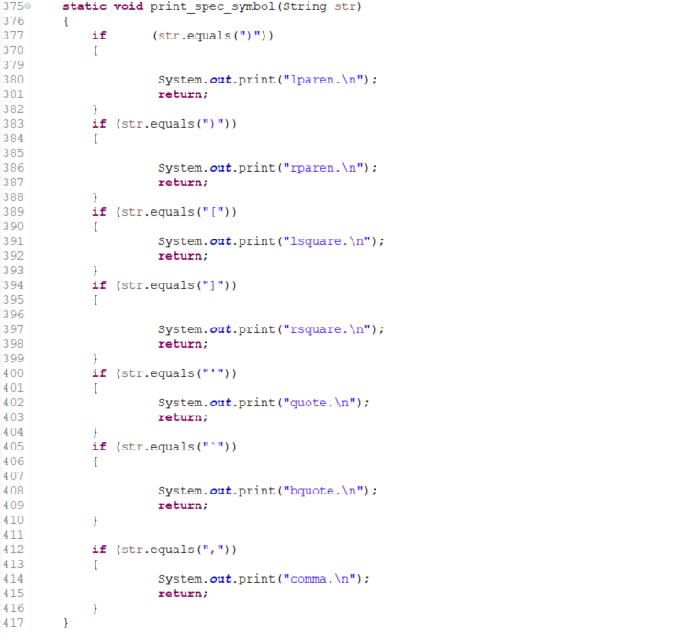

|  |  |  |  |  |
| --- | --- | --- | --- | --- |
| Block Number | Lines | Entry | Exit | Function Calls |
| 1 | 377 | 377 | 377 |  |
| 2 | 380, 381 | 380 | 381 |  |
| 3 | 383 | 383 | 383 |  |
| 4 | 386, 387 | 386 | 387 |  |
| 5 | 389 | 389 | 389 |  |
| 6 | 391, 392 | 391 | 392 |  |
| 7 | 394 | 394 | 394 |  |
| 8 | 396, 397 | 396 | 397 |  |
| 9 | 400 | 400 | 400 |  |
| 10 | 402, 403 | 402 | 403 |  |
| 11 | 405 | 405 | 405 |  |
| 12 | 408, 409 | 408 | 409 |  |
| 13 | 412 | 412 | 412 |  |
| 14 | 414, 415 | 414 | 415 |  |

# is_spec_symbol

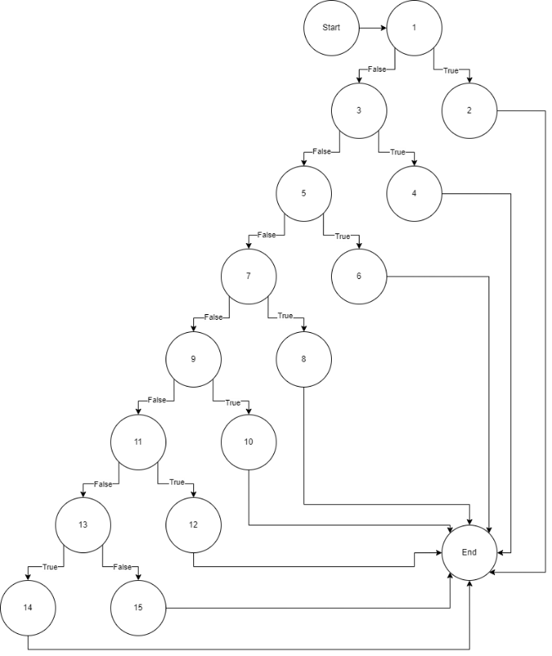

|  |  |  |  |  |
| --- | --- | --- | --- | --- |
| Block Number | Lines | Entry | Exit | Function Calls |
| 1 | 426 | 426 | 426 |  |
| 2 | 428 | 428 | 428 |  |
| 3 | 430 | 430 | 430 |  |
| 4 | 432 | 432 | 432 |  |
| 5 | 434 | 434 | 434 |  |
| 6 | 436 | 436 | 436 |  |
| 7 | 438 | 438 | 438 |  |
| 8 | 440 | 440 | 440 |  |
| 9 | 442 | 442 | 442 |  |
| 10 | 444 | 444 | 444 |  |
| 11 | 446 | 446 | 446 |  |
| 12 | 448 | 448 | 448 |  |
| 13 | 450 | 450 | 450 |  |
| 14 | 452 | 452 | 452 |  |
| 15 | 454 | 454 | 454 |  |

# main

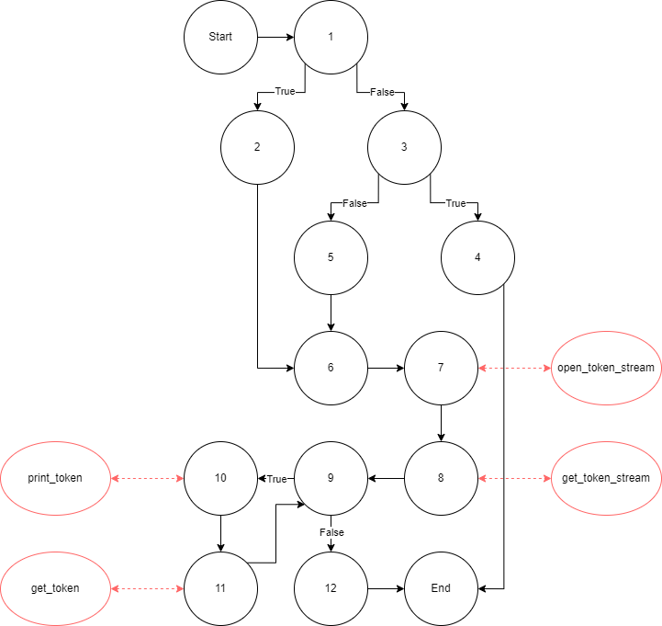

|  |  |  |  |  |
| --- | --- | --- | --- | --- |
| Block Number | Lines | Entry | Exit | Function Calls |
| 1 | 458, 459 | 458 | 459 |  |
| 2 | 460 | 460 | 460 |  |
| 3 | 461 | 461 | 461 |  |
| 4 | 462 | 462 | 462 |  |
| 5 | 464, 465 | 464 | 465 |  |
| 6 | 467 | 467 | 467 |  |
| 7 | 468 | 468 | 468 | open_token_stream |
| 8 | 469 | 469 | 469 | get_token |
| 9 | 470 | 470 | 470 |  |
| 10 | 471 | 471 | 471 | print_token |
| 11 | 472 | 472 | 472 | get_token |
| 12 | 476 | 476 | 476 |  |